The Masonry Foundation Grant Application

Texas Masonry Council: Grant Submission

Project Description

The Texas Masonry Council is a 501(c)(6) nonprofit trade association comprised of masonry contractors and suppliers in the state of Texas working together to promote the expanded use and benefits of masonry. We are passionate about strengthening and growing the masonry industry. We are committed to serving our members by providing a voice of advocacy and adequate workforce through focused education and programming. TMC’s Marketing and Communications Strategic Plan goals directly align with the goals of The Masonry Foundation: Grow the size and influence of our organizations, raise awareness of the benefits of masonry, and educate EVERYONE.

It’s been called a strategic tool with irresistible power by Harvard Business Review, and “the major business lesson of 2014” by Entrepreneur Magazine. What exciting new 21st-century technology is this? It is the age-old art of storytelling--something humans have done since they first started communicating. It is harder than ever to look for jobs, seek partnerships, and overcome the saturated online information market, it’s not enough to just offer up the facts about you or your industry anymore. A great story can launch an iconic brand, build an empire, or even revolutionize an industry. Successful entrepreneurs know that stories are inspiring, persuasive, thought-provoking, and most importantly they move people to action and get results. According to an article found in the New York Times, these days you must be compelling, unforgettable, funny and smart--and you need to answer the most important question: “What makes you special?” Bottom line: you need to have a good story.

The Masonry Foundation grant funding presents members with the opportunity to make a difference and secure the industry’s success today and in the future--a goal that is also the core of TMC’s mission. Major challenges in the industry include educating young professionals about the industry, engaging architects/engineers, utilizing new technologies/media to engage new audiences, and promoting local projects/developments both locally and nationally for recognition.

We want to take some of the existing in-depth research that has already been conducted concerning the cost effectiveness of masonry fire safe construction and turn it into an innovative, engaging, and educational story. STORYTELLING. This story will target architects, engineers, general contractors, building owners/investors, and consumers. We aim to inspire young professionals to give masonry a fresh look as the premier design choice in terms of safety, durability, beauty, and, ultimately, in cost.

In short, the industry has produced volumes of technical and engineering data showing the superiority of our product. But, unless we start crafting compelling and thought-provoking stories, much of that great information will continue to sit in books on shelves and never make it to the architects, builders, educators, and consumers we intend.

Project Scope and Objectives

Under the guidance of the Texas Masonry Council, this document requests grant funding to support the creation of an innovative, engaging, and educational digital marketing kit that will turn existing masonry construction cost studies and reports into usable information targeted at architects, engineers, general contractors, building owners/investors, and consumers.

Part of the scope of the project will be to identify existing studies and documents that would benefit from a focused effort to market their conclusions to the appropriate audiences. One document that has already been identified titled “Initial Cost of Construction: Multi-Residential Structures” prepared by Walter G. M. Schneider III, Ph. D provides a wealth of information concerning the cost effectiveness of fireproof construction materials in multi-family construction. The study concludes that masonry and concrete based construction was less expensive than lightweight conventional wood frame construction in some cases and within just a few percentage points more expensive in other cases. Sample pages of the report are included in Attachment A at the end of this document.
But this information has not been broadcast in an effective manner to decision makers in the design and building professions. The perception that constructing buildings to be truly fireproof comes at a cost that is too high for owners and consumers is still pervasive. The information provided within Dr. Schneider’s study, and others, must be effectively communicated to our target audiences through better storytelling.

The goals of this initiative are to:
- Publicize and promote the cost effectiveness of fire-proof masonry construction techniques.
- Increase awareness within the professional design community about passive construction techniques such as compartmentalization.
- Educate and engage multiple audiences utilizing already established industry knowledge and expertise about the costs and benefits of masonry construction.
- Tell the story of masonry to new audiences.
- Bring together members of the masonry industry with community leaders, decisionmakers, influencers, and the general public
- Engage the public and consumers through digital media marketing.
- Build collaboration between local and national masonry organizations.

There will be four main deliverables produced over the course of the project:

- Creation of striking visuals and infographics highlighting the cost effectiveness of masonry fire safe construction.
- Develop an AIA CES presentation that can be shared among and used by industry partners that routinely engage architects in continuing education.
- Develop and host a new website to display the new materials and videos created during the project.
- Creation of a professionally produced 3-4 minute explainer video concerning the cost effectiveness of fire safe masonry construction. This video will be produced in a way that short 15-30 second clips can be shared routinely by industry groups in nationwide digital media efforts.

Background Information

The idea to turn some of the great technical work coming out of the masonry industry into a cutting edge, modern digital media marketing campaign has been discussed at the Texas Masonry Council for over a year. The information produced by MCAA, NCMA, BIA, and other national masonry organizations is professional, informative, and leaves no doubt that in almost all cases, masonry is the best long-term choice for a building material. But, often, that information never gets filtered down to the just out of school architect, or the young family choosing their first home. This work would be unique in that many advocacy programs do not tell the story of their trade, nor the impacts their products have in communities today. Through our research and in working with local communities, it has become clear that multiple marketing/educational methods are necessary to target a variable audience – a mixture of qualitative and quantitative information, as well as exciting ways to engage the senses. Visuals and videos are recalled much more promptly than text or other sensory inputs – 65% for visual content versus a mere 10% for pure text. Visualization works from a human perspective because we respond to and process visual data better than any other type of data. In fact, the human brain process images 60,000 times faster than text, and 90 percent of information transmitted to the brain is visual. Because humans are visual by nature, we aim to use this skill to enhance educational efforts and organizational effectiveness.

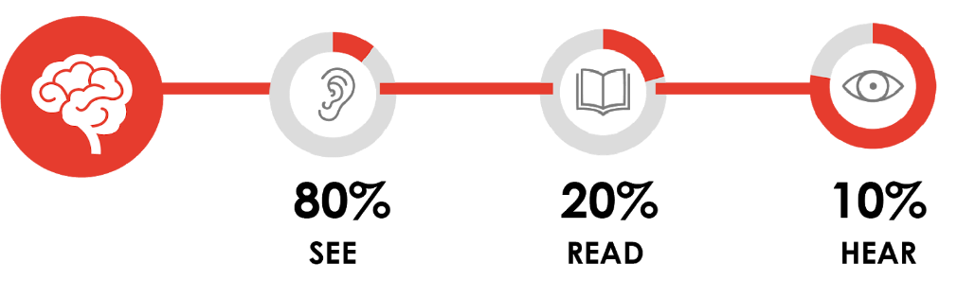

Providing media content and tagging users provides a great opportunity for engaging in conversations with community and industry ambassadors, as well as addressing questions or concerns people may have about our organization and its cause. Moreover, social media is a great place to thank your advocates and supporters publicly. Tagging them in photos and posts not only makes them feel appreciated, it also allows posts to be shared with their followers, thereby extending your reach to their audiences. Underlying our media strategy is this: help your stakeholders and help them help others. We need to make it easy for the young architect to show their client the cost effectiveness of our product.

Proposed Timeline

[2020]
- January 2020 - Graphic Design for printed materials.
  - TMC Staff will begin graphic design and layout for new printed material and infographics showcasing the cost study.
- February 2020 - Website Design and AIA CES Presentation
  - TMC Staff will begin work on a website that will host all new designed materials, infographics, videos, and presentations concerning the multifamily construction cost study and anticipated future retail, commercial, education, single-family cost studies. Complete AIA Professional Provider registration.
- March 2020 - Storyboard 3-4 Explainer Video
  - TMC staff will begin work on planning and storyboarding a 3-4 minute Explainer Video that is targeted at design professionals, policy makers, and consumers.
- March - April 2020 - Video Production
  - TMC staff will engage with a qualified local film production company to produce an engaging, professional level video detailing the benefits and cost effectiveness of fireproof masonry construction in multifamily development.

Summary of Qualifications

The work will be led and coordinated by staff from the Texas Masonry Council. Staff members have decades of combined experience in various aspects of the masonry industry. The staff also has years of experience within the urban/city planning profession where many decisions are made every day concerning the types of building materials allowed in new development. The experience in public engagement, public involvement and advocacy will help this program target specific groups of people that could benefit from more masonry education, training, and awareness. TMC staff also has an experienced graphic artist that will produce new printed material for the project. Examples of recent work can be seen in Attachment B at the end of this document.

TMC has some limited experience with making short videos for various activities within our organization. However, the ultimate vision for this project calls for video production experience far beyond the capabilities of our staff. A highly experienced local video production company will be engaged for the final filming, editing, and overall production of the 3-4 minute explainer video. The anticipated costs and budget were development with information from preliminary discussions from 2 video production companies.

In addition to the experience contained within our staff, TMC will partner with other applicable organizations to help organize distribution of the final products to anyone that could benefit from more masonry education - architects, engineers, public officials, and consumers.

Anticipated Impacts

The immediate anticipated impact is to get our existing professional cost/benefit studies into the hands of building and design decision makers nationwide. The deliverables from this project are meant to be shared with organizations across the masonry industry with the intention of making it much easier to influence local decision makers. Infographics, short video clips, and the AIA CES presentation can be customized for specific parts of the country.

An important secondary impact will be to get this information into the hands of our own industry. TMC routinely speaks with our own members who have no idea the wealth of resources available to them to help in their own daily challenges in telling the masonry story. It is useful and helpful for large organizations like MCAA, NCMA, BIA, and TMC to advocate and educate about masonry. But, those efforts can be multiplied 1000x if all of the various contractor, producer, supplier members of those organizations had the ability to easily tell that same story on a daily basis with their customers, clients, and elected officials.

The longer term anticipated impact deals with how we change the way we tell the story of masonry. Our industry is an ancient one that is routinely under attack by the newest, coolest, more “affordable” products. We must all collaborate and find a better way to tell the story of our ancient brand using the most cutting edge and newest technologies available to us.

We have found that we can effectively change the perceptions surrounding building materials at a local level with hands on activities and materials. Some of TMC’s milestone successes were the result of taking local residents and decision makers on walking tours of their own communities, showing them first-hand the impacts building materials have on the health of their community. This grant proposal is an effort to expand our audience and expose more [local citizens, decision makers, students, architects, builders, professors, and others] to the benefits of masonry.

Let’s use the digital marketing age to take people on a virtual walkthrough of the benefits of masonry fire safe construction.

Budget and Proposed Payment Procedure

The program proposes local funding for the grant to begin on January 1, 2020. The new printed material, infographics, AIA material, and website will be developed from local funding during the January and February time frame. The $5,000 matching grant funds from the MCAA Foundation would be distributed March 1st to fund the engagement of a professional video production firm in Texas.
Payment details will be arranged with the Texas Masonry Council Executive Director.
Program Funding and Expenditures
The proposed grant funding sources and expenditures are outlined in the following table. The estimated total ($10,000) reflects a 50/50 split in local organization match funds and MCAA Foundation grant funds.

Project Funding | Source | Type | Amount
Texas Masonry Council - In kind staff time for graphic design, AIA coordination, etc... | Local | In kind | $2800
Texas Masonry Council - Cash expenditure for website creation, hosting, and AIA registration | Local | Cash | $2200
Total Local Funding |  |  | $5000
MCAA Foundation - Cash expenditure for engagement of video production company | MCAA | Cash | $5000
Total MCAA Foundation Funding |  |  | $5000
Total Funding |  |  | $10,000

Expenses | Est. Rate | Quantity | Estimate
TMC Staff time for Graphic Design of materials and infographics | $35/hr | 40 hours | $1400
TMC Staff time for video storyboard and planning | $35/hr | 20 hours | $700
TMC Staff time for AIA Presentation | $35/hr | 20 hours | $700
Professional Video Production Company | Variable |  | $5000
AIA Professional Provider Registration |  |  | $500
Website Domain Registration 3-5 years of hosting |  |  | $500
Printed Materials and Infographics |  |  | $1200
ESTIMATED TOTAL EXPENSES |  |  | $10,000

Reporting Schedule

TMC will update the MCAA Foundation of the grant program and deliverables progress three times during the course of work.
Report 1:
February 1, 2019:
Report will cover the creation of new printed material and infographics.

Report 2:
March 1, 2019
Report will cover the creation of website and AIA CES material.

Report 3:
April 1, 2019
Report will cover the efforts to outline and storyboard the 3-4 minute explainer video as well as the efforts to secure a professional video production firm located in Texas.

After the completion of the video production and finalization of the website it will be important to track the response to the new material. TMC will provide a 6- and 12-month post project update to MCAA that tracks the exposure of the material to our target audiences.

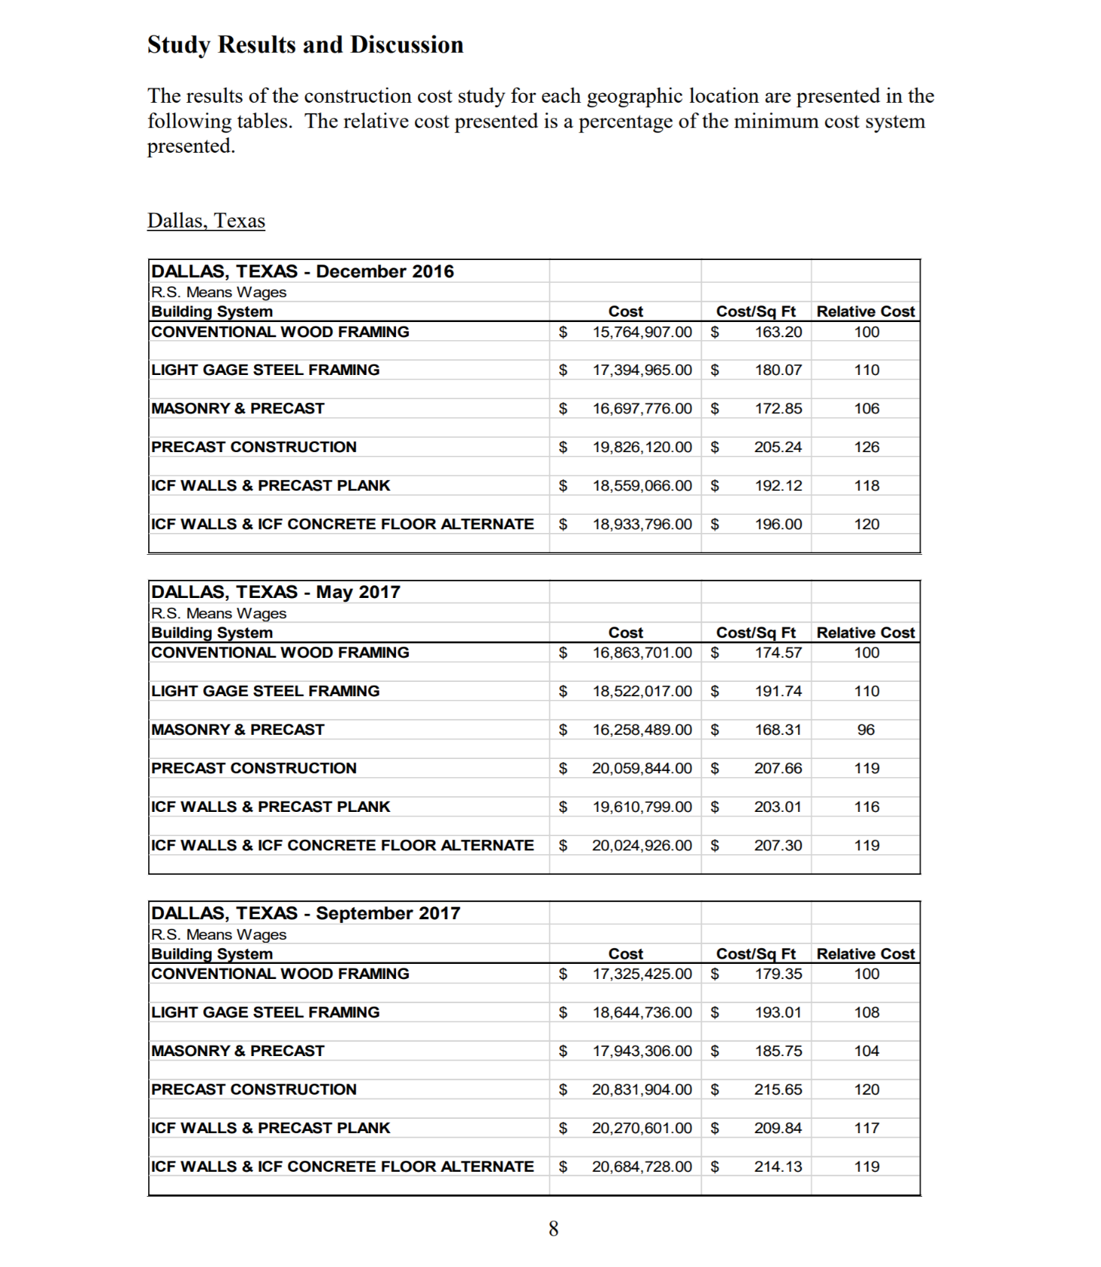
Appendix A – Initial Cost of Construction: Multi-family Residence Structures.

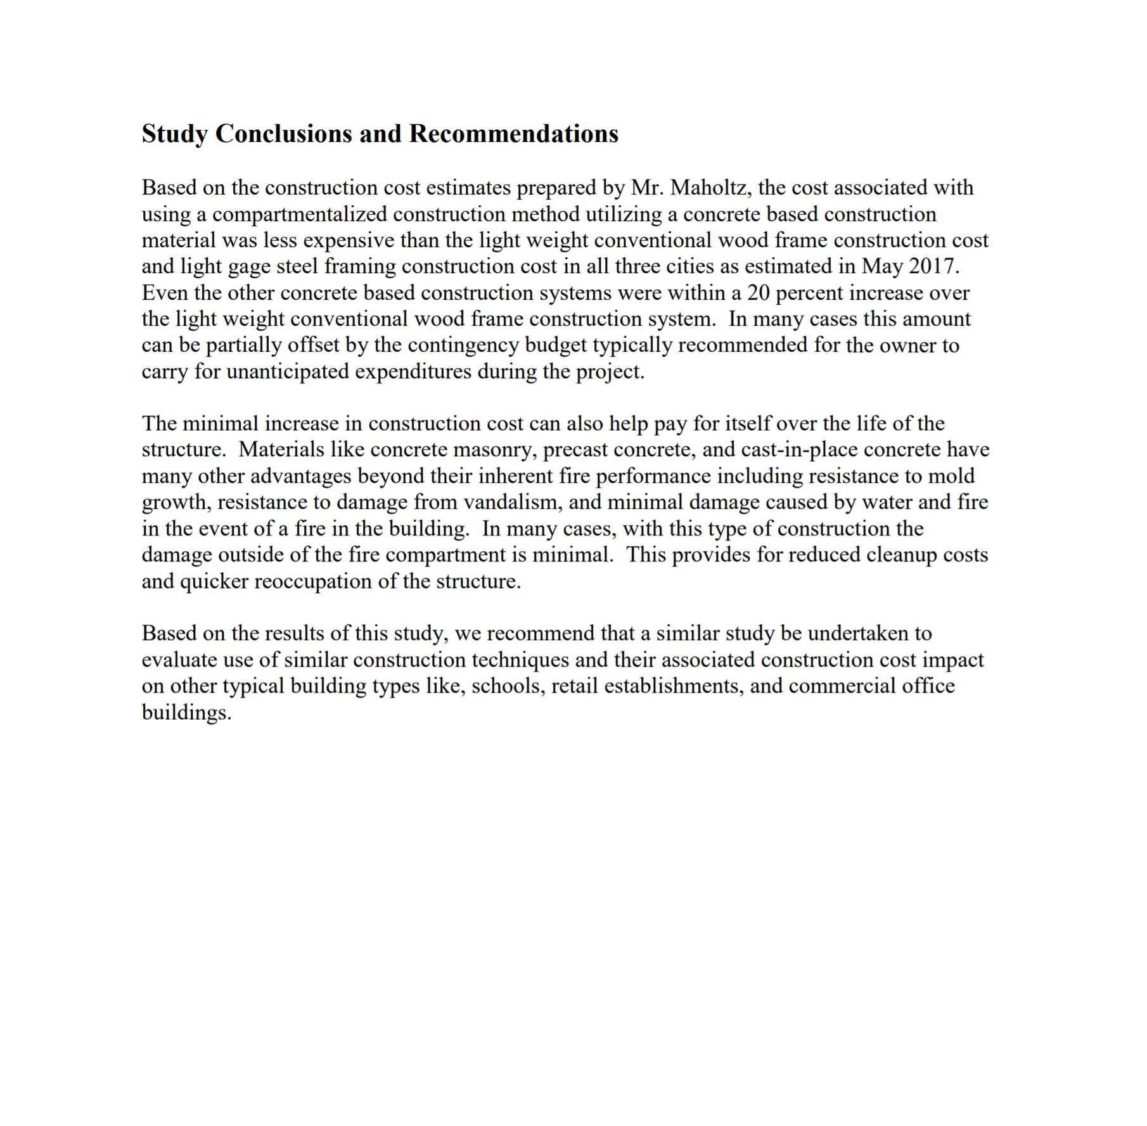

Appendix B: TMC Graphic Design Examples

